Follow INC  Team Bajrang Dal | Target Audience: 14-25yrs old  Gamer Type: regular gamer, casual puzzler  Target Platforms: PC  Genre: Puzzle, Dystopia  Number of Players: Singleplayer  Projected Release Date: November 3rd

Concept Image

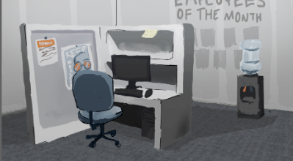

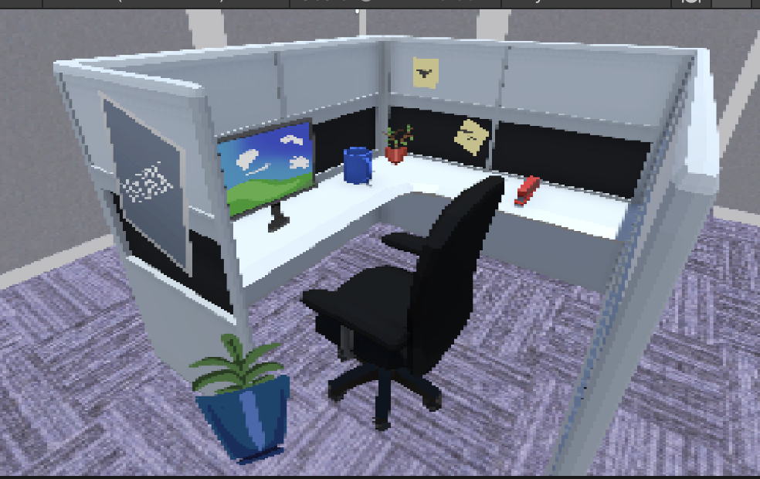

Elevator Pitch (High Concept Statement)

Follow INC is a unique twist on the puzzler set in a corporate dystopian setting. The player is the latest hire by the eponymous Follow INC and is expected to consist of (audience). Throughout the course of the game, the player will be asked to follow a detailed set of instructions to advance, however, these instructions are incompletable as written/directed (ex: you are told to deliver a folder somewhere, only the folder is not in the location you have been directed to pick it up). The lengths the player must go to get around these instructional failures will get increasingly difficult as the game goes on, with additional environmental puzzles also coming into play, such as vent puzzles. As they complete these they will eventually complete ‘Floors’ and take elevators to the next floor, climbing the corporate ladder until they are at the very top.
This game takes place inside the offices of Follow INC, a soulless corporate office building. The other major environment factor is Ms. Direction, an AI assistant who provides the directions and feedback and is supposed to be rather annoying. The player is to be majorly constrained by the linear nature of the game (1 puzzle after the other in a linear order) and then by their own knowledge/skill and effort. The game is planned to have a majorly 3D low poly graphical feel interspersed with some elements of higher detailed 2D elements, such as portraits of company bigshots. This all then culminates into the target emotion of Dissonance we want the player to feel, the idea that things are mismatching and wrong.

Feature Set (Pillars of the Game)

- Bamboozled directions Puzzles
- Environmental Puzzles
  - Quick-time Painting
  - Vent Puzzles
  - Better Call Saul Report Puzzles
- Multiple ways to solve puzzles
- Mismatched Art Styles (low poly 3D and higher def 2D elements)
- Corporate Office Setting

Design Influences / Competitive Analysis
- Stanley Parable for vibe/setting
- Lethal Company/REPO for aesthetic
- WarioWare in puzzles
- Better Call Saul for reports puzzles
- Competitive Analysis/how we are different
  - Bamboozled directions puzzles differentiate us from the competition by adding new dimensions to how are other puzzle mechanics are implemented
  - Corporate setting adds an additional layer of progression to the game
  - Ms Direction as an element adds unique narrative flair to the puzzles

Game Flow and/or Game Loop

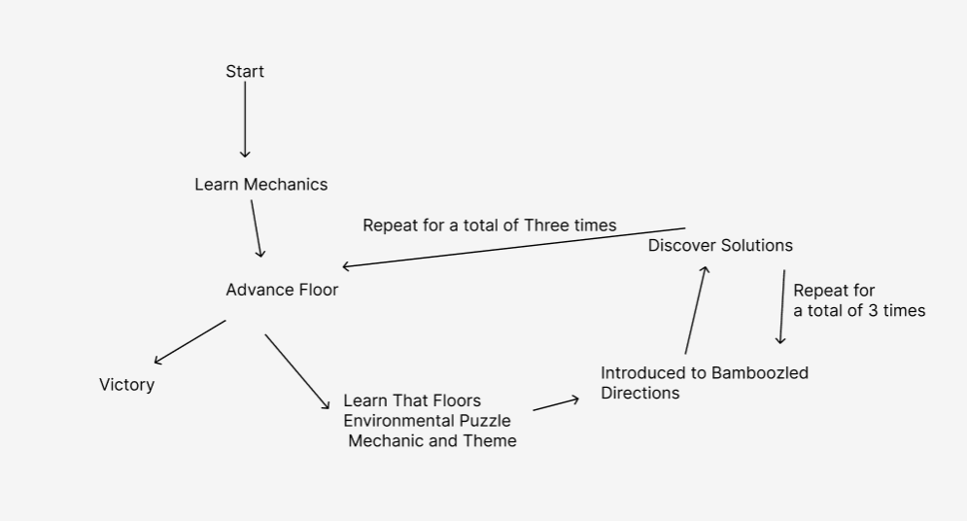

Team Roles
Design:
- Tyler Eppig
- Nolan Wong
Art:
- Liv English-Saunders
- Sean Kavanaugh
Programming:
- Elliot Grinnel
- Palash Mathur
- Aden Seymour
Production:
- Palash Mathur
Audio:
- Tyler Eppig

SWOT Analysis
Internal | Strengths | Weaknesses
Internal | What does your team do well?  Programming capability, Designer capacity, Artistic passion, ideation  What unique resources can you draw on?  Intercultural backgrounds, 7 people’s worth of unique life experience.  What competitive advantages do you have over your competition?  Unique mechanical structure and topical premise | What are your teams weaknesses?  Audio skills and capacity  Where do you have fewer resources than others?  Audio  What competitive weaknesses do you have over your competition?  Audio
External | Opportunities | Threats
External | What game industry opportunities are open to you?  Professional feedback from experienced professors, free online distribution  What game industry trends could you take advantage of?  Rise in indie game success and growing public dissatisfaction against corporations  How can you turn your strengths into opportunities?  Create a well-rounded experience that targets current consumer sentiments | What game industry threats could harm your game? (consumer behaviour, changes in technology, …)  Intense Indie game competition, increasing digital regulation  What is your competition doing?  Bite-sized memory puzzles, Multiplayer experiences, big-budget action/horror puzzles  What threats do your weaknesses expose you to?  The possibility of lacking a key element and therefore a full experience

Please delete the instructions below upon completion of section.
Do a SWOT (Strengths, Weaknesses, Opportunities, and Threats) analysis for your game project. Fill in the table above. To learn more about SWOT Analysis read this and watch this.

Scope Management
- Green Light
  - 3 floors (unique layout), 3 tasks per floor
  - 1 unique mechanic added each floor
- Yellow Light
  - Ms. Direction UI
  - Music
  - Solution based Feedback
- Red Light
  - Lobby
  - Voice Acting

Timeline
- Concept Art (done)
- Basic environment and props (partway done)
- Prototype-first level/floor (10/8)
  - Speed art, tasks, layout (art included)
- Alpha (10/22)
  - Vent(floor 2) and gate puzzles, tasks, layout(art included)
  - Report (floor 3), tasks, layout(art included)
- Done (11/3)
  - Layout and puzzle refinement

